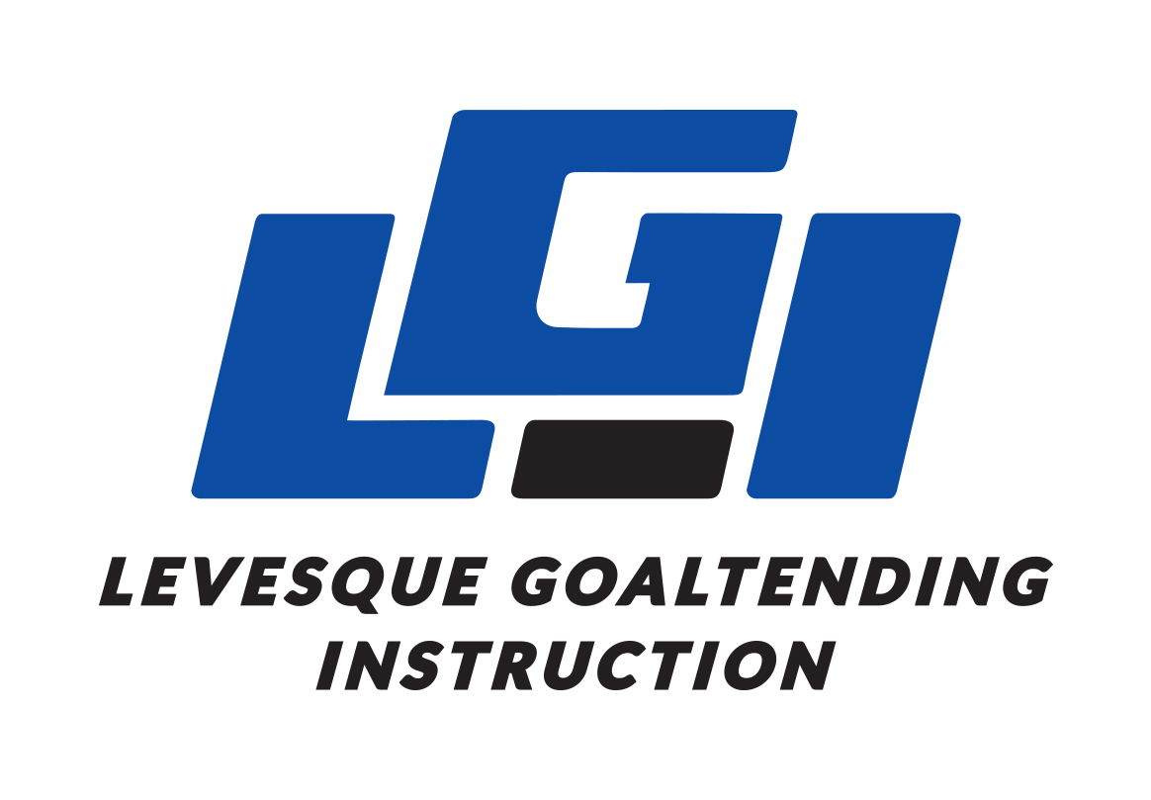 | Levesque Goaltending Instruction  Camp Registration Form

Personal Information (of registered goalie)
Full Name
Birth Date (MM/DD/YY)
Street Address
City, Province
Postal Code
Email
Phone Number
Minor Hockey Level

Emergency Contact
Name
Phone Number
Relationship

Camp Selection

___Beginner – August 16th-20th, $499 + GST
___Intermediate – August 16th-20th, $599 + GST
___Advanced – July 19th - 23rd, $699 + GST

Payment Options Include…

E-transfer, Cash, Cheque, or Credit card

___Visa ___MasterCard ___American Express

Name on Card
Card Number
Expiry Date
Security Code

Please select ___50% deposit, with remaining 50% being processed first of the month the camp in running
___Full payment

Levesque Goaltending Instruction
Waiver and Release of Liability

In consideration of being allowed to participate in any way in Levesque Goaltending Instruction hockey athletic/sports program related events and activities, the undersigned acknowledges, appreciates and agrees that:

- Because of the nature of the sport, the risk of injury from activities involved with this program is significant and while particular rules, equipment and personal discipline may reduce the risk, the risk of serious injury does exist; and,
- I knowingly and freely assume all such risks, both known and unknown and assume full responsibility for my participation; and,
- I willingly agree to comply with the stated and customary terms and conditions for participation. If however, I observe any unusual significant hazard during my presence or participation, I will remove myself from participation and bring such to the attention of the nearest official immediately; and,
- I, for myself and on behalf of the heirs, assigns, personal representatives and next of kin, hereby release and hold harmless Levesque Goaltending Instruction, their officers, officials, agents and/employees, other participants, sponsoring agencies, sponsors, advertisers and if applicable, owners and lessors of premises used to conduct the event (Releases) with respect to any and all injury, disability, death, or loss or damage to person or property.

I have read the release of liability and assumption of risk agreement; fully understand its terms and conditions.

Participant’s Name: Participant’s Signature:

Witness: Date:

For participants of Minority Age
(Under 18 years of age at time of registration)

This is to certify that I as a parent/guardian with legal responsibility for this participant, do consent and agree to his/her release as provided above all the Releases, and for myself, my heirs, assigns, and next of kin, I release and agree to indemnity the Releases from any and all liabilities incident to my minor child’s involvement or participation in these programs as provided above.

Parent / guardian’s signature: Emergency phone number:

Witness: Date:

Levesque Goaltending Instruction
Social Media Release

**Optional
For participants of Minority Age
(Under 18 years of age at time of registration)

This is to certify that I as a parent/guardian with legal responsibility for this participant allow LGI to post video and/or pictures of on and off ice training sessions on social media forums only controlled and registered with LGI.

Parent / guardian’s signature: Participants Name:

Witness: Date:

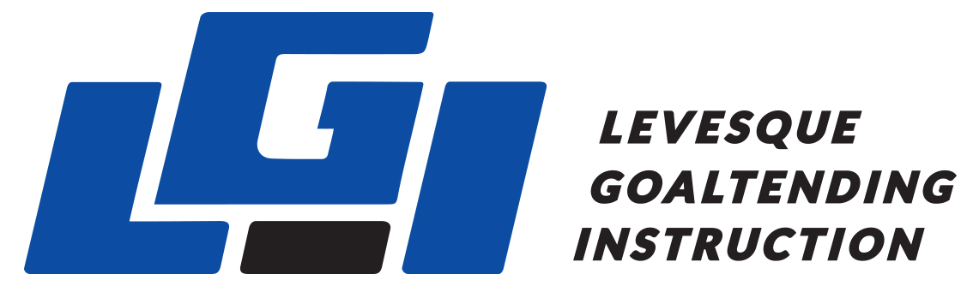

Assumption of Risk and Waiver of Liability Relating to Coronavirus/Covid-19
This waiver & declaration must be completed prior to or upon visiting Levesque Goaltending Instruction (LGI) and before participating in any activity.

The novel coronavirus, COVID-19 has been declared a worldwide pandemic by the World Health Organization. COVID-19 is extremely contagious and is known to spread mainly by contact from person to person. Consequently, local, provincial and federal governmental authorities recommend various measures and prohibit a variety of behaviors, in order to reduce the spread of the virus.

Levesque Goaltending Instruction (LGI) and its members commit themselves to comply with the requirements and recommendations of Alberta National, Provincial and local Public Health and other governmental authorities, and to put in place and adopt all necessary measures to that effect. However, LGI cannot guarantee that you (or your child, if participant is a minor/ or the person you are the tutor or legal guardian of) will not become infected with COVID-19. Further, attending the activities could increase your (or your child, if participant is a minor/ or the person you are the tutor or legal guardian of) risk of contracting COVID-19, despite all preventative measures put in place.
______________________________________________________________________
By signing this document,
- I acknowledge the highly contagious nature of COVID-19 and I voluntarily assume the risk that I (or my child, if participant is a minor/ or the person I am the tutor or legal guardian of) could be exposed or infected by COVID-19 by participating in LGI’s activities. Being exposed or infected by COVID-19 may particularly lead to injuries, diseases or other illnesses.

- I declare that I (or my child, if participant is a minor/ or the person I am the tutor or legal guardian of) am participating voluntarily in LGI’s activities.

- I declare that neither I (or my child, if participant is a minor/ or the person I am the tutor or legal guardian of) nor anyone in my household, have experienced cold or flu-like symptoms in the last 14 days (including fever, cough, sore throat, respiratory illness, difficulty breathing).

- If I (or my child, if participant is a minor/ or the person I am the tutor or legal guardian of) experience, or if anyone in my household experiences any cold or flu-like symptoms after submitting this declaration, I (or my child, if participant is a minor/ or the person I am the tutor or legal guardian of) will not attend any of LGI’s activities, programs or services for at least 10 days from the start of symptoms, or until symptoms resolve, whichever is longer.

- I (or my child, if participant is a minor/ or the person I am the tutor or legal guardian of), or any member of my household travelled to or had a lay-over in any country outside Canada in the past 14 days. I (or my child, if participant is a minor/ or the person I am the tutor or legal guardian of) will not attend any of LGI’s activities, programs or services until at least 14 days have passed since the date of return.

- I (or my child, if participant is a minor/ or the person I am the tutor or legal guardian of) agree to the requirements and recommendations of National, Provincial and local Public Health and other governmental authorities and to those special safety regulations put in place by LGI as it pertains the Covid-19 Coronavirus and to adopt all necessary measures to those effects.

- I (or my child, if participant is a minor/ or the person I am the tutor or legal guardian of) agree that, by filling out and signing this waiver and agreeing to the terms and conditions set out in it, I am giving up my legal rights to sue LGI and its coaches, in the event that I (or my child, if participant is a minor/ or the person I am the tutor or legal guardian of), contracts the Covid-19 Coronavirus.

This document will remain in effect until LGI, as per the direction of the national, provincial and local government and health officials, determines that the acknowledgments in this declaration are no longer required.

This document is in addition to and does not replace all other LGI waivers.

I HAVE SIGNED THIS DOCUMENT FREELY AND WITH FULL KNOWLEDGE.

______________________________ __________________________________
Name of participant (print) Name of parent/tutor/ legal guardian (print)
(if participant is minor or cannot legally give consent)

______________________________ __________________________________
Signature of participant Signature of parent/tutor/legal guardian

Place/Date: _______________________________________

