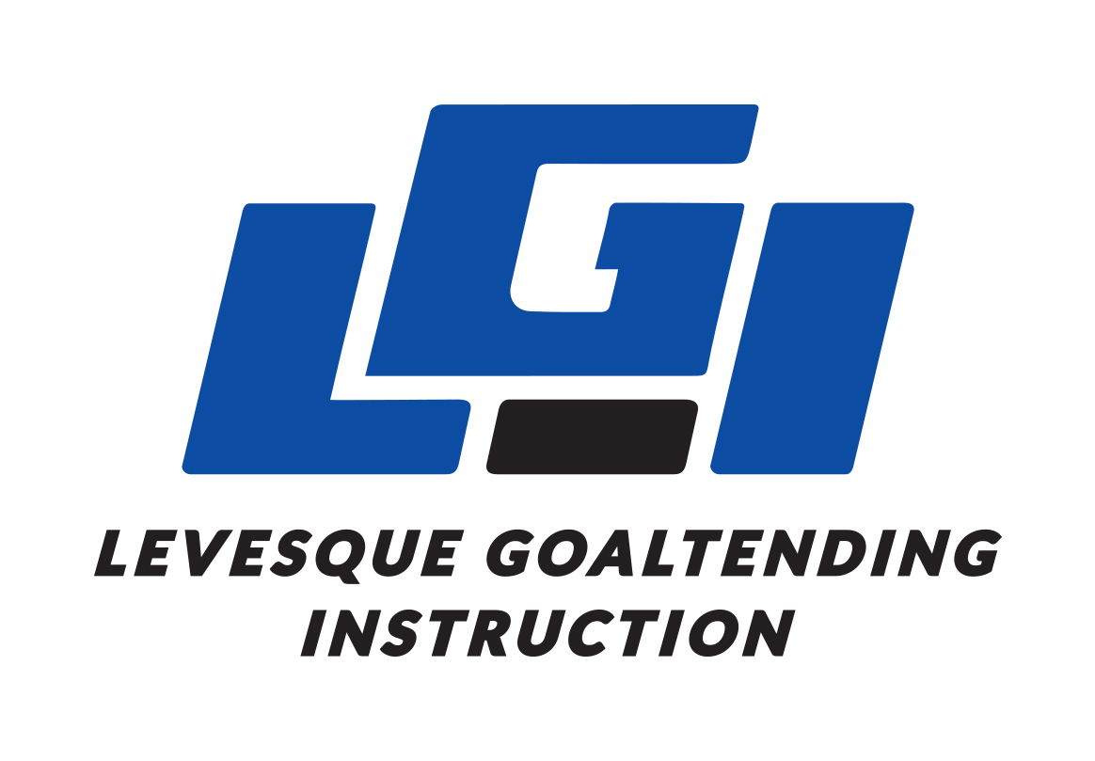 | Levesque Goaltending Instruction  Camp Registration Form

Personal Information (of registered goalie)
Full Name
Birth Date (MM/DD/YY)
Street Address
City, Province
Postal Code
Email
Phone Number
Minor Hockey Level

Emergency Contact
Name
Phone Number
Relationship

Camp Selection

___Beginner – July 25th-29th, $525 + GST
___Intermediate – July 25th-29th, $625 + GST
___Advanced – July 25th-29th, $725 + GST

Payment Options Include…

E-transfer, Cash, Cheque, or Credit card

___Visa ___MasterCard ___American Express

Name on Card
Card Number
Expiry Date
Security Code

Please select ___50% deposit, with remaining 50% being processed first of the month the camp in running
___Full payment

Levesque Goaltending Instruction
Waiver and Release of Liability

In consideration of being allowed to participate in any way in Levesque Goaltending Instruction hockey athletic/sports program related events and activities, the undersigned acknowledges, appreciates and agrees that:

- Because of the nature of the sport, the risk of injury from activities involved with this program is significant and while particular rules, equipment and personal discipline may reduce the risk, the risk of serious injury does exist; and,
- I knowingly and freely assume all such risks, both known and unknown and assume full responsibility for my participation; and,
- I willingly agree to comply with the stated and customary terms and conditions for participation. If however, I observe any unusual significant hazard during my presence or participation, I will remove myself from participation and bring such to the attention of the nearest official immediately; and,
- I, for myself and on behalf of the heirs, assigns, personal representatives and next of kin, hereby release and hold harmless Levesque Goaltending Instruction, their officers, officials, agents and/employees, other participants, sponsoring agencies, sponsors, advertisers and if applicable, owners and lessors of premises used to conduct the event (Releases) with respect to any and all injury, disability, death, or loss or damage to person or property.

I have read the release of liability and assumption of risk agreement; fully understand its terms and conditions.

Participant’s Name: Participant’s Signature:

Witness: Date:

For participants of Minority Age
(Under 18 years of age at time of registration)

This is to certify that I as a parent/guardian with legal responsibility for this participant, do consent and agree to his/her release as provided above all the Releases, and for myself, my heirs, assigns, and next of kin, I release and agree to indemnity the Releases from any and all liabilities incident to my minor child’s involvement or participation in these programs as provided above.

Parent / guardian’s signature: Emergency phone number:

Witness: Date:

Levesque Goaltending Instruction
Social Media Release

**Optional
For participants of Minority Age
(Under 18 years of age at time of registration)

This is to certify that I as a parent/guardian with legal responsibility for this participant allow LGI to post video and/or pictures of on and off ice training sessions on social media forums only controlled and registered with LGI.

Parent / guardian’s signature: Participants Name:

Witness: Date:

